The Yoko Tsuno File
Collected by: Dick Grune
dick@dickgrune.com

Name: 角洋子 (Tsuno Yōko), = Horn¹, Ocean Child/Western Child²
Born: ~1947 ³ (age undefined after 1972 due to time travels)
Place of Birth: Naka-koshiki-shima, Japan⁴
described as l'île du Songe (The Dream Island) in L'écume de l'aube
Parents: Tsuno Seiki (1916 ³) and Ishida Masako (1930 ³)
Paternal Grandparents: Tsuno Onue (1880 ³) and Lai-Chi / Hikoro

Other family relationships:
Cousin (f) in Hong Kong: Ying (16 - Le dragon de Hong Kong, 24A)
Cousin (m) on Borneo: Izumi (11 - La spirale du temps, 2A2)
Great-uncle (alive in 1943): Tōshio Ishida (11 - La spirale du temps, 29A2)
married to Yukiyo
Great-uncle (alive in 1943): Kiyushi Ishida
bother of Tōshio
Masako's father

Skills and Competences:
Languages: Japanese, French
English (L'écume de l'aube)
Cantonnese⁵ (– L'écume de l'aube, + Le Dragon de Hong Kong)
German⁶ (L'or du Rhin, 16C, 21A&B)
Indonesian (Le jonc céleste, 16B)

Martial Arts: Black Belt Aikido

Pilot's License: Glider D

Helicopter: Gazelle, Jet Ranger, Ecureuil

Further occupations: Photographer's model (20 - L'astrologue de Bruges, 2C)

Notes

The author is extremely accurate with places and things, but less so with times and languages.

Note 1: The family name Tsuno
The family name `Tsuno' does not occur in the official 名字見聞録("Records of names"), but nine out of the 11 names on that list that start with Tsuno (Tsunokawa, et.c) start with 角, = horn.
It is also the first character in 角隠し(tsunokakushi = horn veil), the Japanese bridal cap symbolically “veiling the bride's horns of jealousy, ego and selfishness”.

Note 2: Yoko's first name
Yōko is a traditional Japanese girl's name. It can be written in three ways:
洋子 = Ocean child
洋子 = Western child
陽子 = Sunlight child
Yoko's first name was inspired by Japanese actress Yoko Tani, whose name is spelled 谷洋子, so 洋子 = Ocean child/Western Child seems very appropriate. (Yoko Tani played the role of the space ship doctor Sumiko Ogimura in the 1959 DDR SciFi movie Der schweigende Stern (English title First Spaceship on Venus).

Japanese internet sites write Yoko's name in katakana, avoiding the problem: ヨーコ・ツノ. Here the names are in Western order: Yōko・Tsuno; the katakana confirms the long ō in `Yōko'.

Note 3: Date of Birth
From '11 - La spirale du temps, 31A1' we learn that Yoko's mother Masako is 13 years old in 1943, so Masako is born 1930. This is in agreement with Masako's reactions on the telephone.

L'écume de l'aube tells us:
At the age of 25, Onue Tsuno buys Lai-Chi in HongKong, renamed her Hikoro, and married her.
Two daughters, the dreamy Chizuka and the impetuous Hiromi, and a son, Seiko result.
The daughters marry early, Seiko somewhat later, with Masako Ishida.
More than 10 years later Yoko was born.
At the age of 5, Yoko meets the garden dragon and starts helping her grandfather.
When Onue was 81, Yoko was 14.

In '04 - Aventures électroniques', which takes place in 1970, Yoko cannot be much younger than 22: this places her birth year at 1948 or earlier, which means that Masako married around 1947 at the age of 17 or slightly earlier. But it cannot be much earlier.

When Onue was 81, Yoko was 14. This makes Onue's birth year around 1880. So he bought Lai-Chi around 1905, and married her say 1908. The daughters could be then born about 1910 and 1912, with Seiki born around 1916. This means that he married Masako at the age of 31.

All this sounds very reasonable, but it cannot be reconciled with Seiko and Masako being having been married for more than 10 years before Yoko was born.

Note 4: Place of Birth
The author says on one of the first pages of L'écume de l'aube that we should not look for l'île du Songe, but the drawings in '9 – La fille du vent' give ample evidence.
The map in 6A2 shows the direction in which the plane is approaching Japan, and picture 6B clearly shows the island Naka-Koshiki-shima (中甑島), the Middle Koshiki Island, also spelled 'Naka-Koshikijima', with the 351 connecting it to Kami-Koshiki-shima, through the little island in between. The shapes of the small island and those visible of Kami-Koshiki-shima also fit. The size is as it would look from say 1.5 km high.
The landing in picture 7B2 gives us a good view of the village of Kami-koshiki-cho Taira:

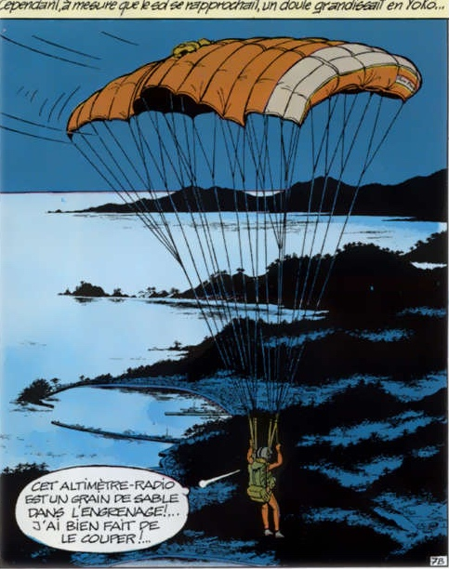

A present-day postcard of Kami-koshiki-cho Taira from almost the same spot for comparison:
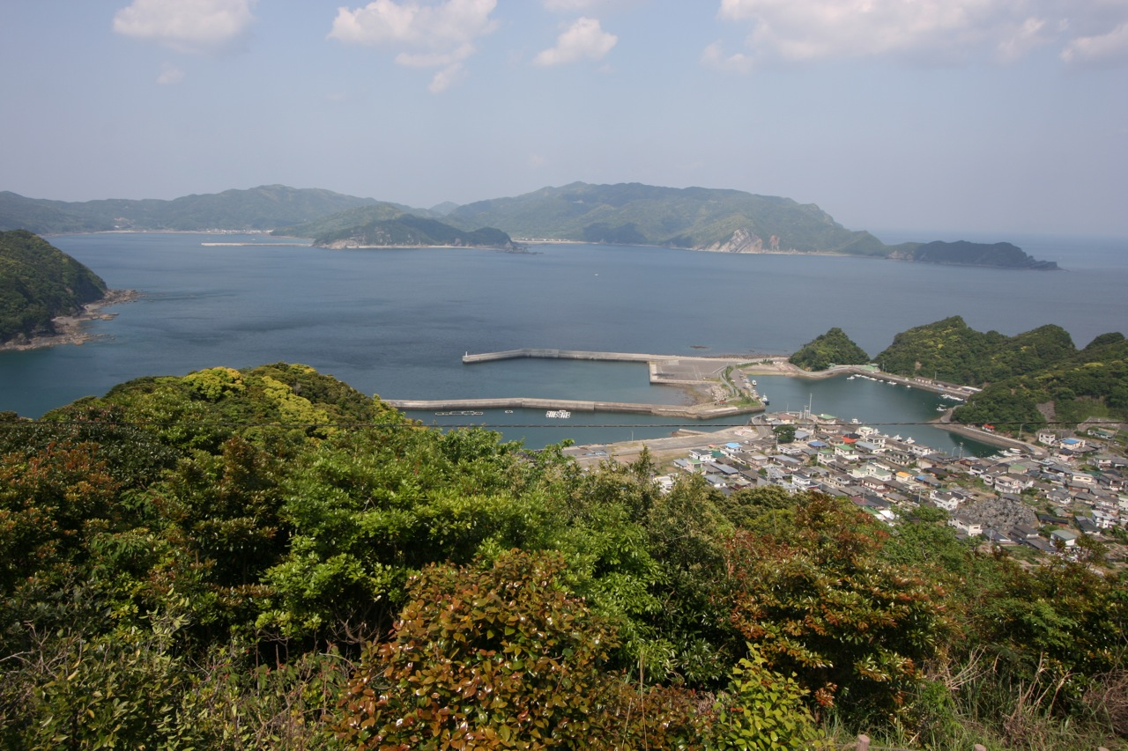
More pictures of these locations can be found on the internet.

The island is in an ideal position to study typhoons in the East Chinese Sea. The map in picture 33B2 confirms this position. The small circle just misses the Koshiki-shima island chain.

The name 'Shôto' in picture 14A1 does not give more information: 'shotō' just means 'island group' (諸島) (and 'shōto' is a martial art).

Note 5:
Yoko hardly speaks any Chinese in L'écume de 'aube.

Some later information can be had from 9 – La fille du vent: picture 2A1 says that Yoko translates the message from a language her friends cannot read, probably Chinese but possibly Japanese. Chen Wu-Cheng's aid cut into the conversation, so he understands French. But he may have reacted in Chinese or Japanese; Vic's reaction may suggest so. Picture 3B1 makes it clear that they had not been speaking French or English, and if Chen Wu-Cheng had spoken French no switch would have been needed. So they spoke either Chinese or Japanese.

In '16 - Le dragon de Hong Kong' Yoko has no problems in conversing with the local population (e.g. 13AB).

Note 6:
In '07 - La frontière de la vie' she speaks freely with the local population. In '19 - L'or du Rhin, 8/9' Yoko gets a position as Japanese/German interpreter.
It may seem that in '19 - L'or du Rhin, 4B & 5A' Yoko needs help from Ingrid to translate some German, but the translations may also be seen as explanations to the reader.

